**RESULTS:**

Shown below are the EMG signals of 3 subjects, and the results of FFT applied on the signals. This has been done for two conditions (barefoot and with heels) while the subject walks for a distance of 1 metre.

**PARTICIPANT 1:**

BAREFOOT WALK:

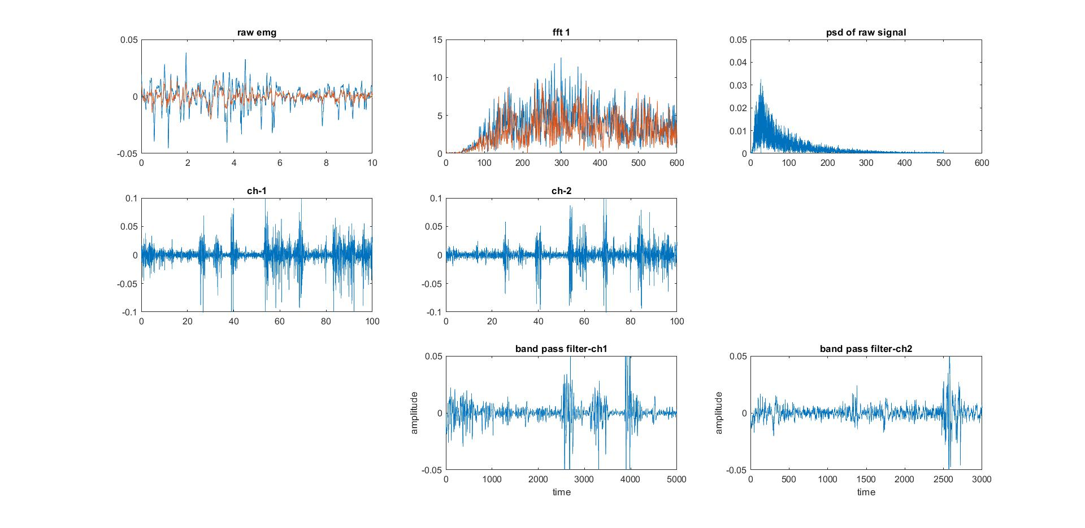

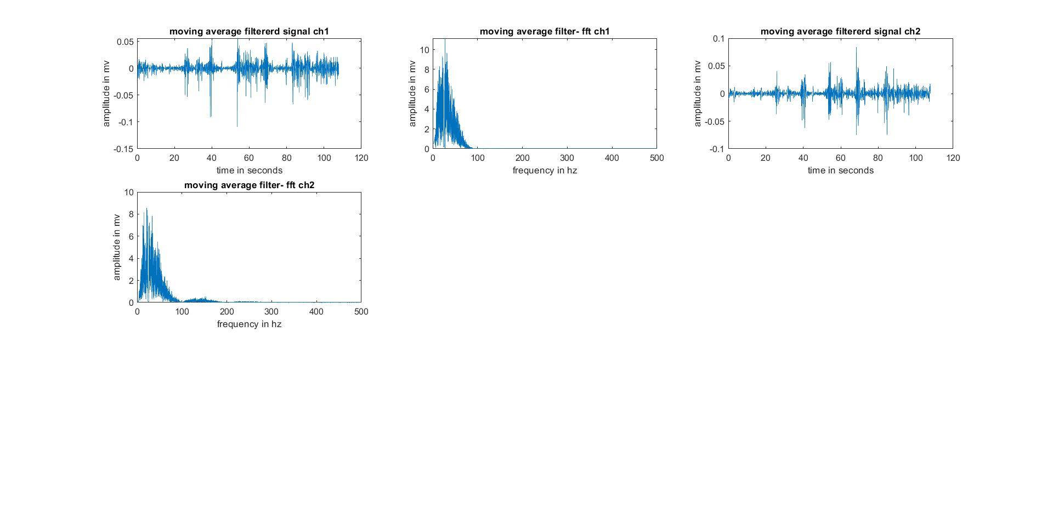

HEEL WALK:

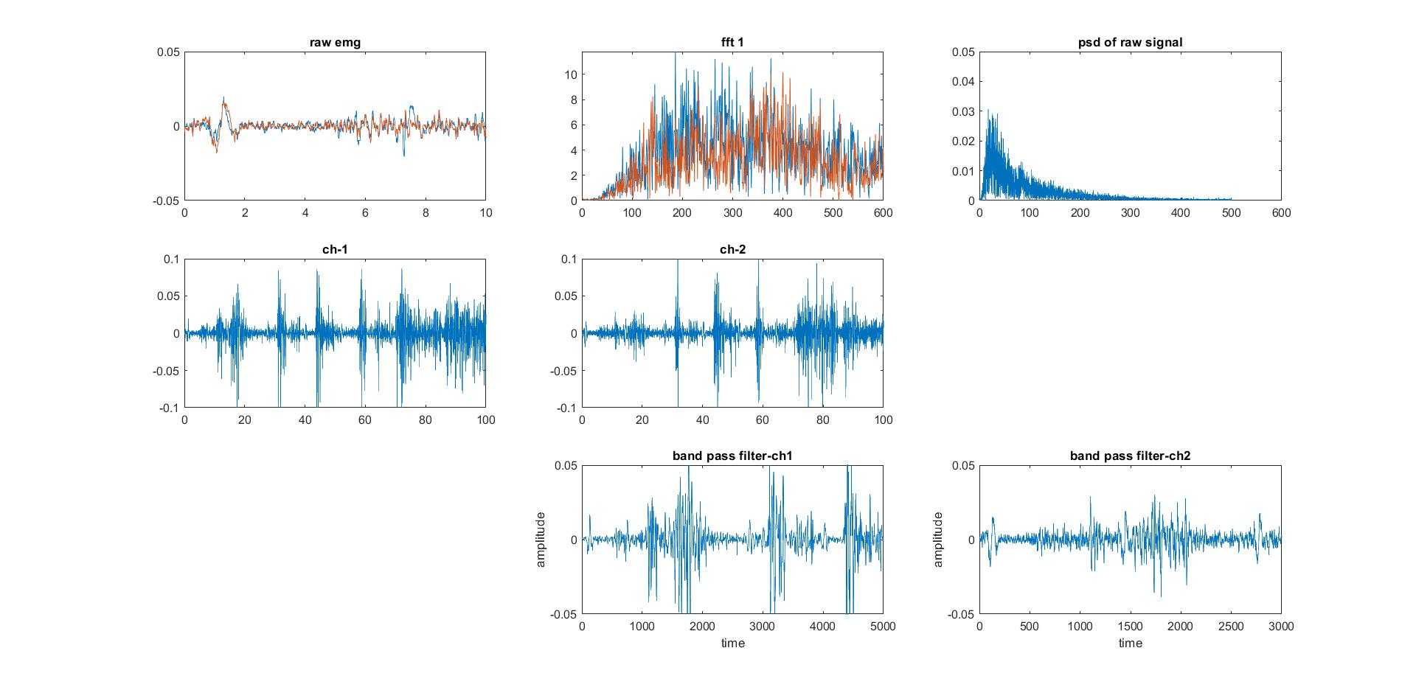

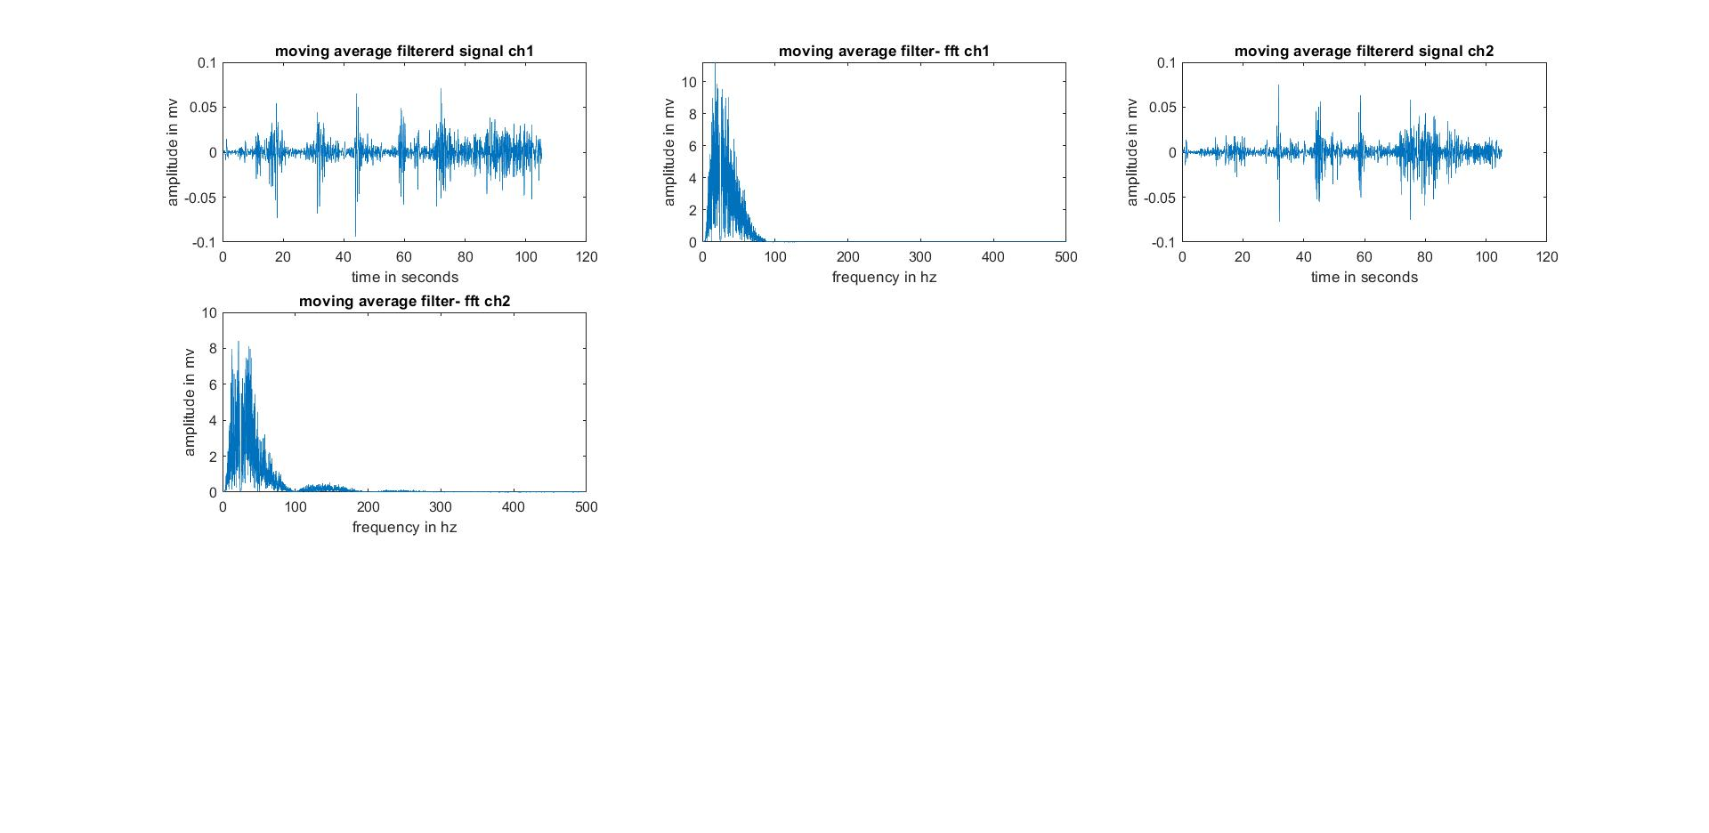

**PARTICIPANT 2:**

BAREFOOT WALK:

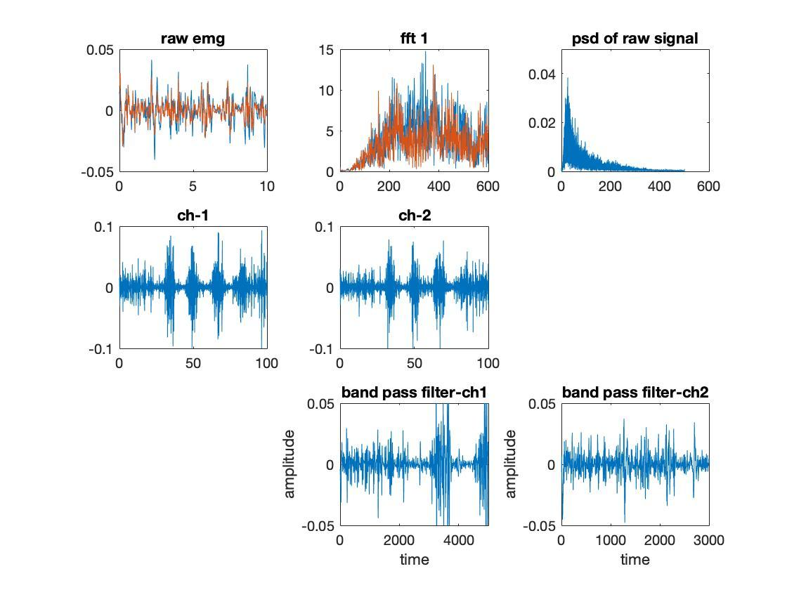

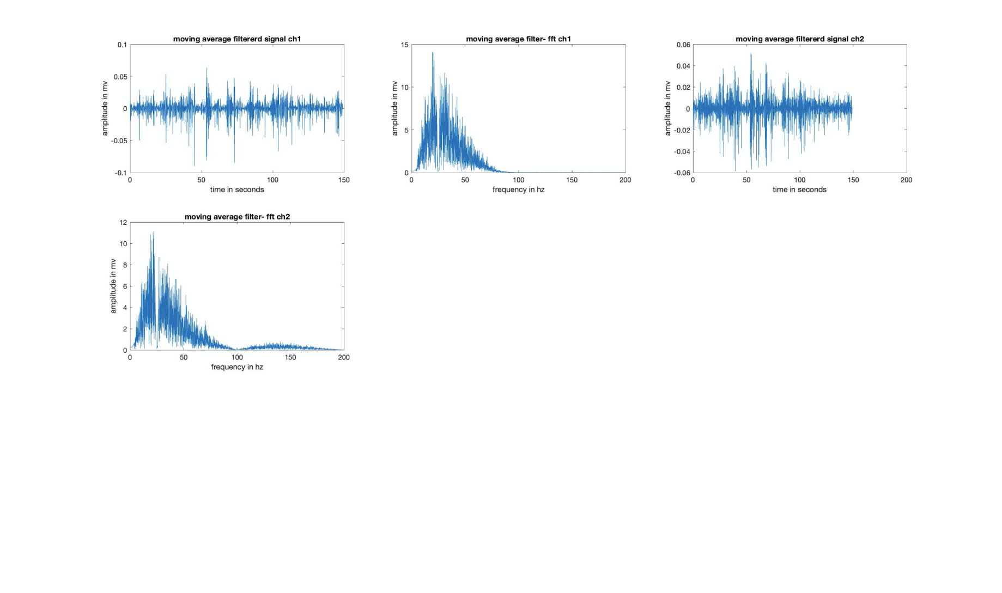

HEEL WALK:

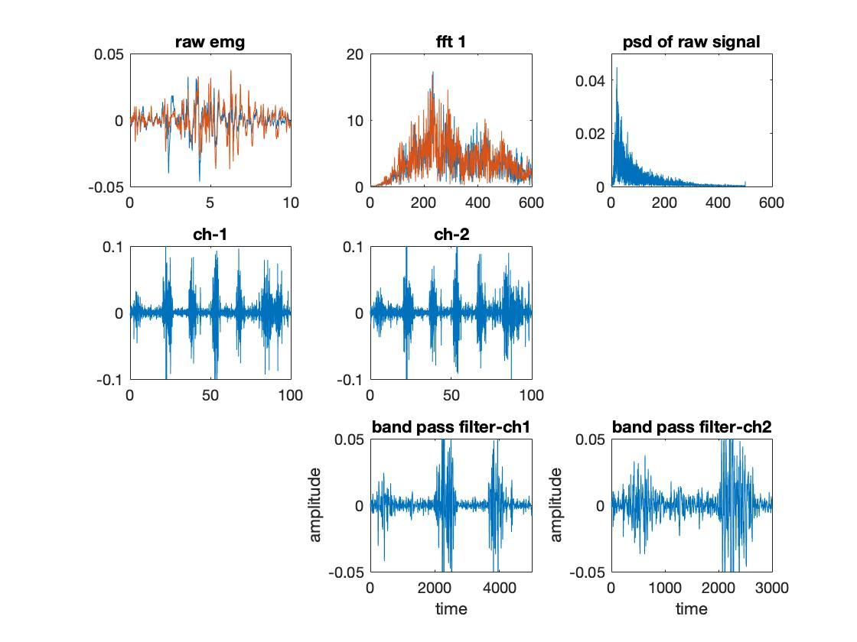

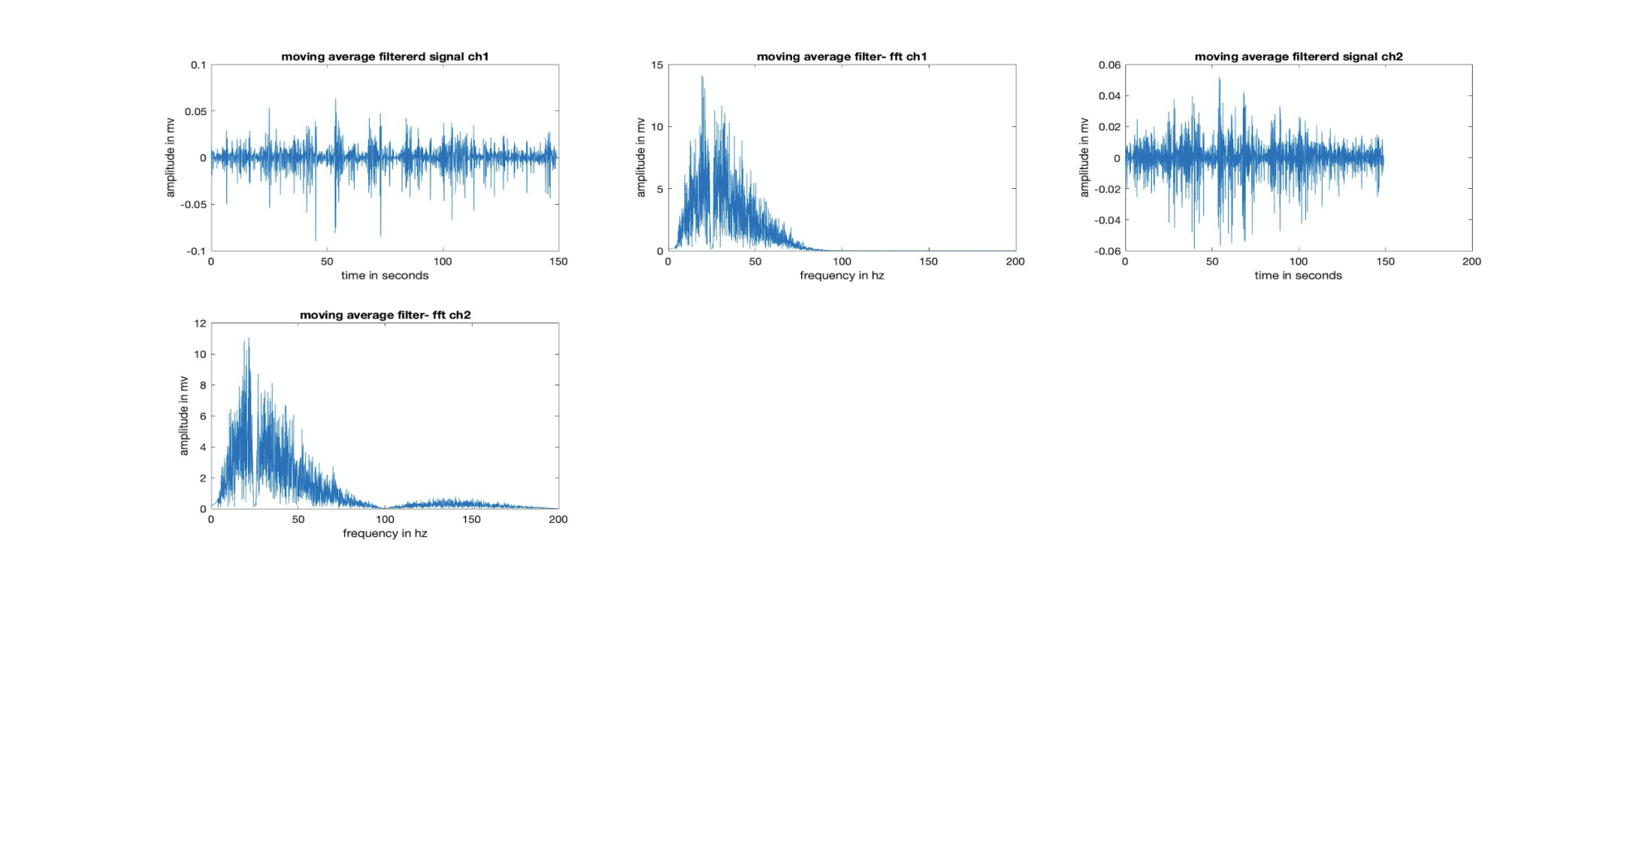

**PARTICIPANT 3:**

BAREFOOT WALK:

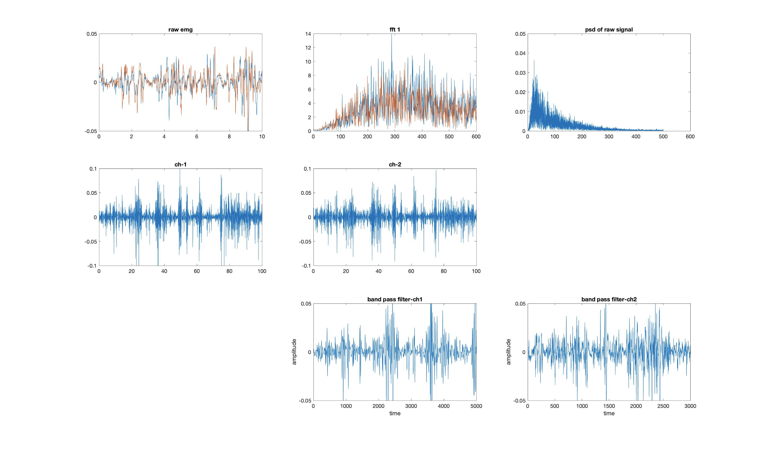

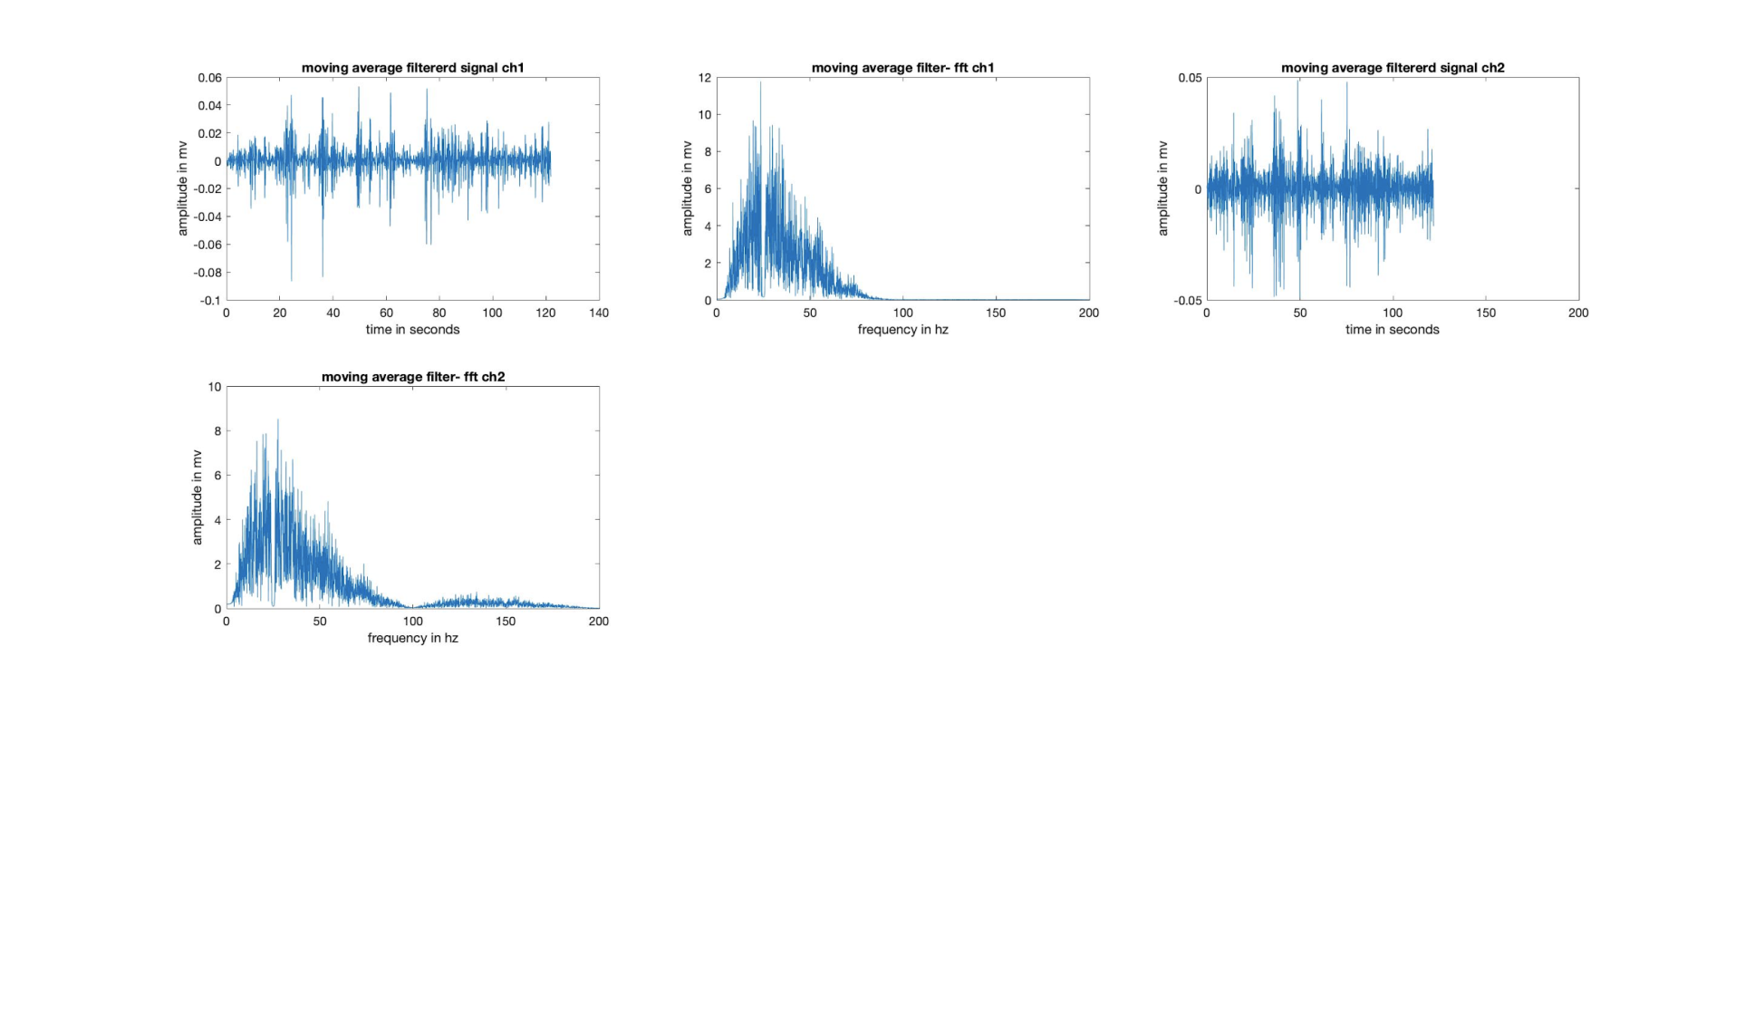

HEEL WALK:

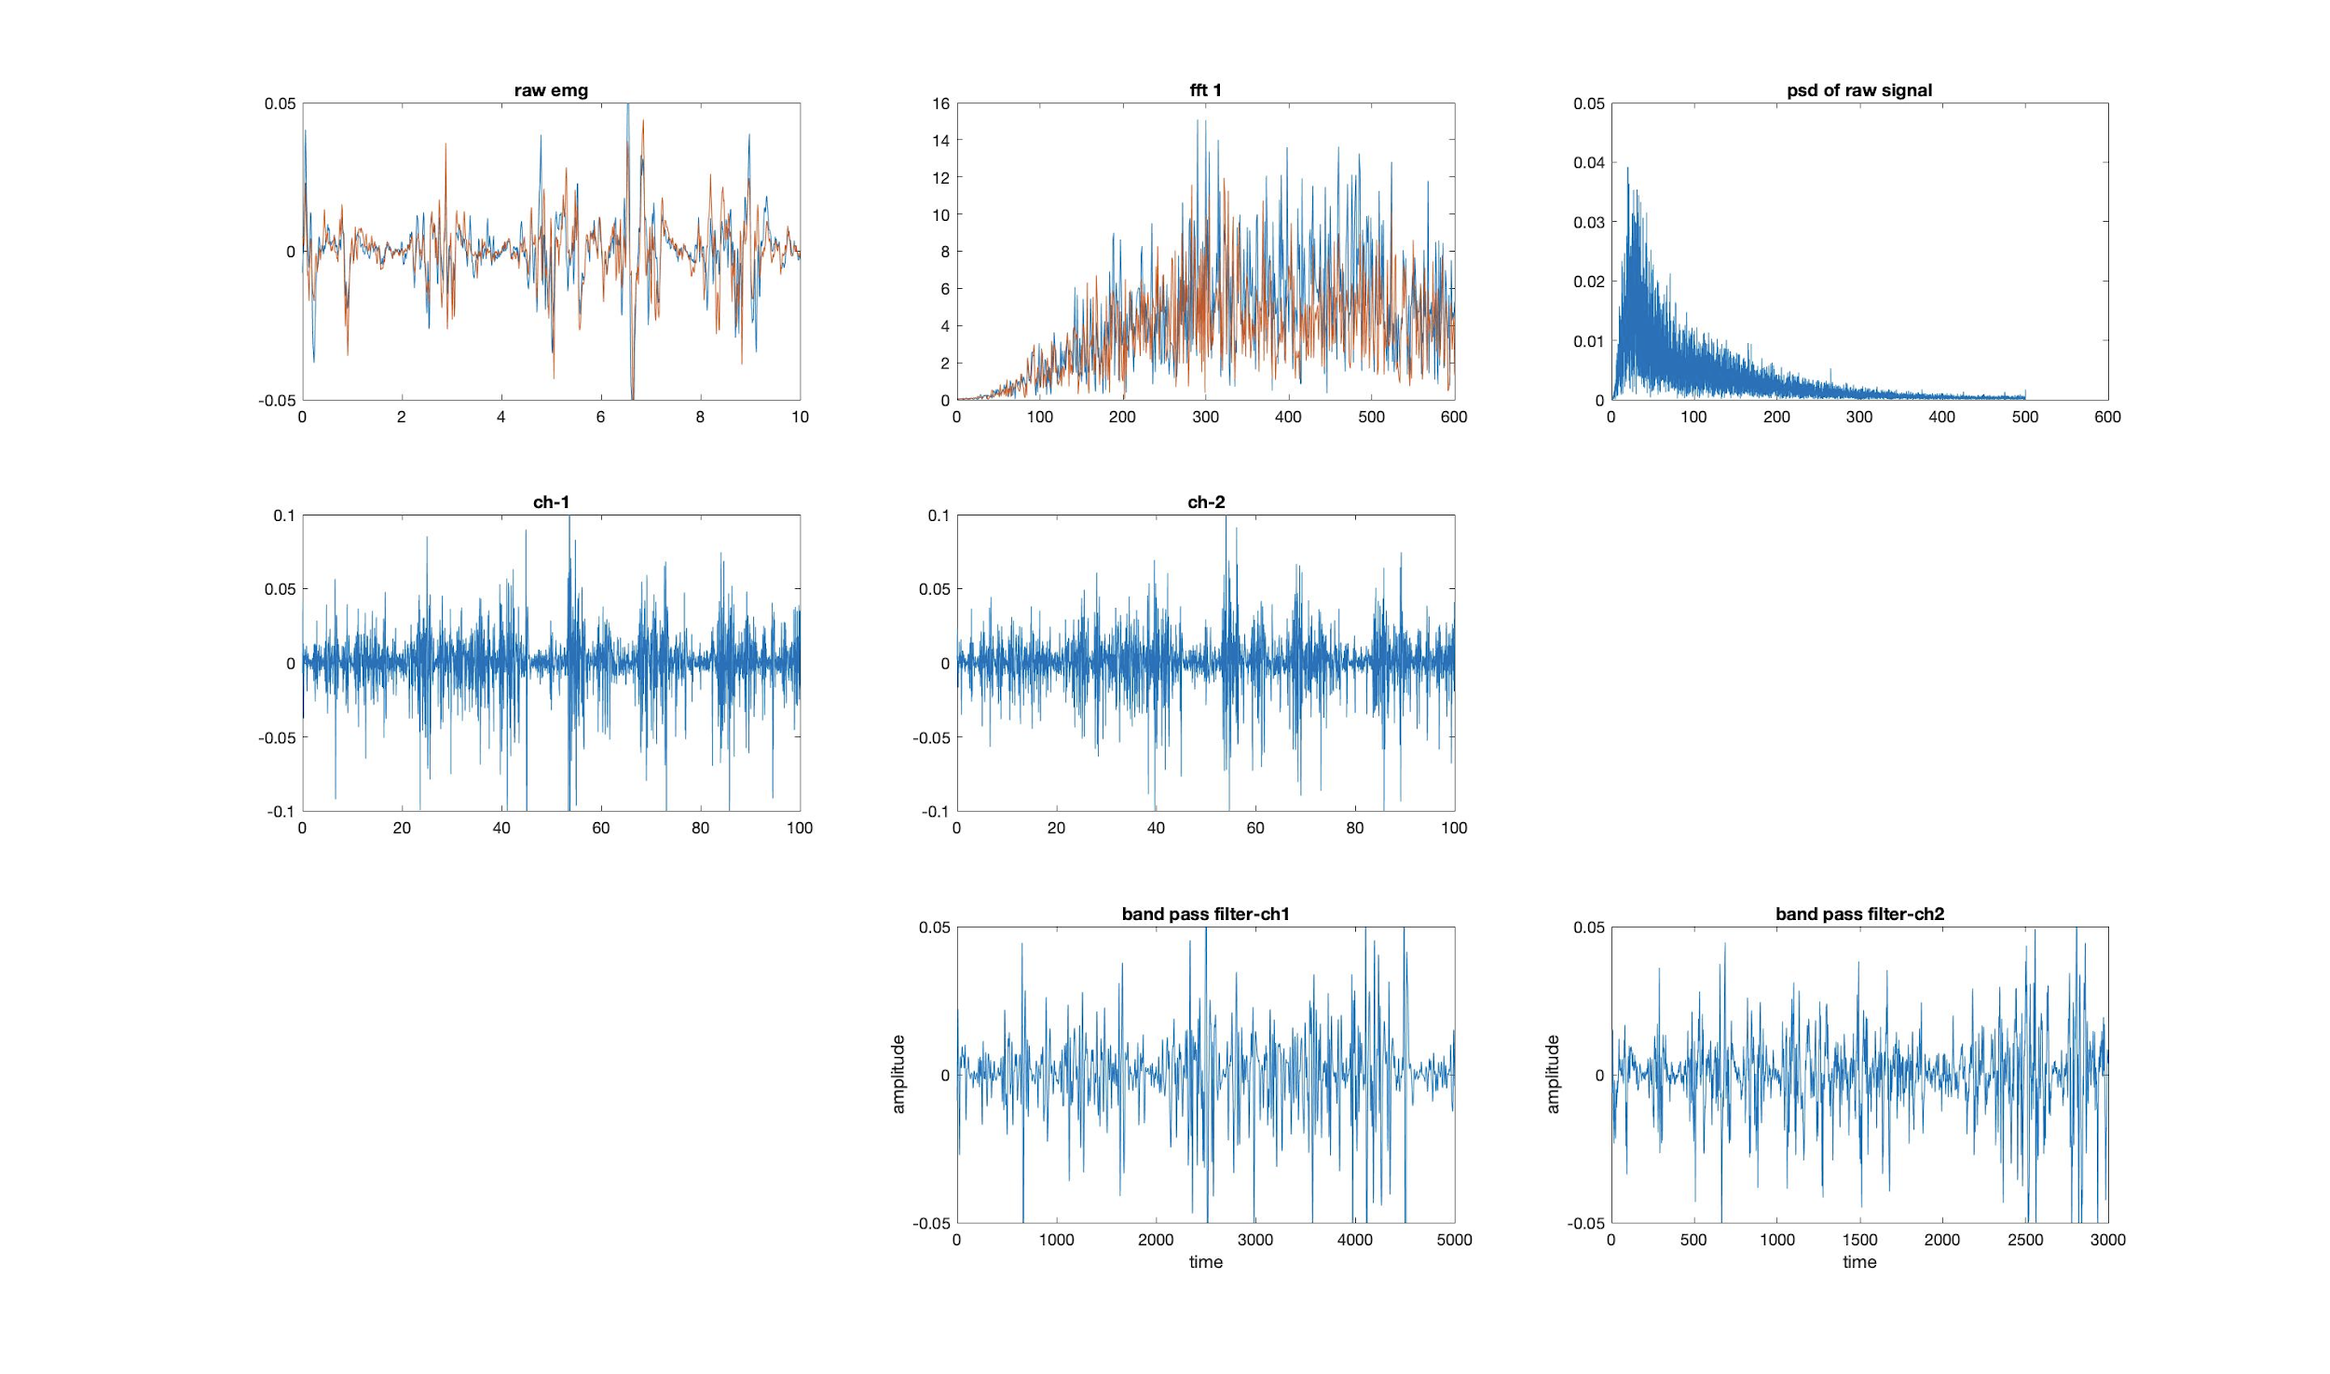  
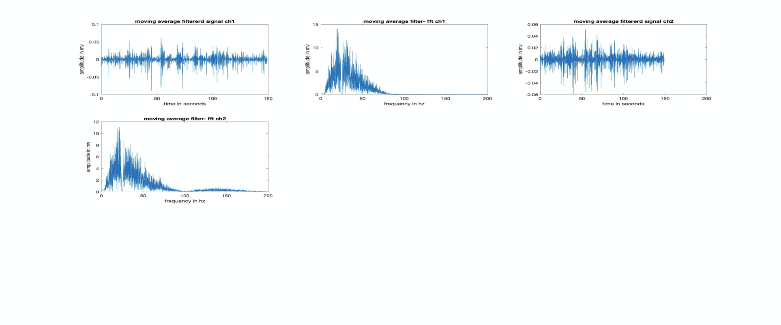

**OBSERVATION:**

Results obtained from ten subjects and their RMS values.

|  |  |  |  |  |
| --- | --- | --- | --- | --- |
| **S.No.** | **RMS Average of heel walk** |  | **RMS Average of barefoot walk** |  |
|  | **Channel 1 (ch1)** | **Channel 2 (ch2)** | **Channel 1 (ch1)** | **Channel 2 (ch2)** |
| **1** | 0.02166 | 0.0146 | 0.01643 | 0.01310 |
| **2** | 0.01116 | 0.0092 | 0.00896 | 0.00800 |
| **3** | 0.00670 | 0.00940 | 0.0053 | 0.0083 |
| **4** | 0.01170 | 0.02000 | 0.01120 | 0.0107 |
| **5** | 0.0123 | 0.01000 | 0.0116 | 0.00973 |
| **6** | 0.0116 | 0.0098 | 0.01100 | 0.00873 |
| **7** | 0.0101 | 0.00996 | 0.00963 | 0.01016 |
| **8** | 0.0108 | 0.0117 | 0.0112 | 0.0112 |
| **9** | 0.00836 | 0.01063 | 0.00830 | 0.00926 |
| **10** | 0.01123 | 0.01276 | 0.014066 | 0.02516 |
| Mean | 0.011562 | 0.011806 | 0.010770 | 0.011436 |